Download and get started with the Stories Online For Autism (SOFA) app (bath.ac.uk)

Potential Challenges
- Sense of belonging
- Struggles with literacy (reading, writing, spelling).
- Difficulties with reading and listening comprehension.

Views

- While social use of the English language might appear okay on a surface level, they are likely to struggle with the more academic language used in class.
- Adults working with them need to understand the difference between social language and academic language acquisition. A simple description of the basic interpersonal communication skills (BICS) required for social communication and the cognitive academic language proficiency (CALP) required for learning has been provided in the appendix section.

- Difficulty following conversations or instructions
- Find reading and other schoolwork difficult
- Exhibit behavioural problems
- Difficulties making friends.

Effective support should focus on understanding the impact of language on pupil’s ability to access the curriculum, as well as supporting pupil to develop their social skills, so they can feel an improved sense of belonging with their peers.

Suggestions
- Topics should be broken down into smaller units and information presented in simple language and in small manageable chunks.
- A classroom environment that provides lots of contextual cues to aid understanding.
- To understand the meaning of key subject vocabulary, teachers should consider the pre-teaching of key words prior to lessons.
- Allowed additional time to think and respond.
- Adults spending time with pupil at the beginning of tasks to
- a) make sure that he understands what to do and,
- b) help him to get started on tasks as necessary.
- Teach the first 100 high frequency words using the precision monitoring approach.
- Sessions on building social skills. Consider the possibility of initiating a ‘circle of friends’ intervention pupil.
- Reading and writing exercises to be appropriately differentiated both in class and for homework.
- Social stories.

Explaining BICS and CALP

Experts such as Jim Cummins explain that there is a difference between social and academic language acquisition as explained below:

Basic Interpersonal Communication Skills
Basic Interpersonal Communication Skills (BICS) refers to language skills that we need in social situations. An example is the day-to-day language we need to interact socially with other people. Social interactions are usually context embedded, in order words, they occur in a meaningful social context. This allows English language learners to communicate easily (employing BIC skills) when on the playground, in the lunchroom, playing sports etc. Because social interactions involve a lot of visual clues to support our understanding of what is being communicated, they are not very demanding cognitively. The language required is not specialised. These language skills are usually believed to develop within six months to two years after arrival into a new country where the language of communication differs from a one’s own first language (learning a new language).
What is important to be aware of is not to assume that a child is proficient in a language when they demonstrate good social English.

Cognitive Academic Language Proficiency
CALP refers to the type of language skills we require for formal academic learning. This includes listening, speaking, reading, and writing about subject area content material. This level of language learning is essential for students to succeed in school. Students need time and support to become proficient in academic areas. This is usually believed to take from five to seven years to develop. Research evidence (Thomas & Collier, 1995) has shown that if a child has no prior schooling or has no support in native language development, it may take seven to ten years to catch up to their peers.
Academic language acquisition isn't just the understanding of content area vocabulary. It includes skills such as comparing, classifying, synthesising, evaluating, and inferring. Academic language tasks are context reduced. Information is read from a textbook or presented by the teacher. As a student gets older the context of academic tasks becomes more and more reduced and increasingly challenging for English language learners.
The language also becomes more cognitively demanding. New ideas, concepts and language are presented to the students at the same time.
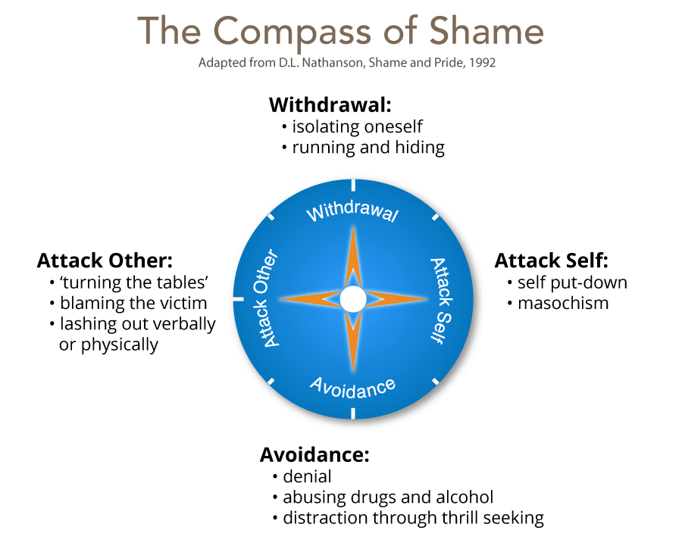

Some considerations: Mindset: Cognition and learning and emotional regulation.
- What is the pupil’s desire/motivation for learning?
- is learning about looking smart in every situation, proving themself and never failing, or
- is it about taking risk, learning, and thriving on challenges?
- How do they evaluate situations?
- Do they think of challenges in terms of success or failure, looking smart or dumb, or
- Do they see tasks as opportunity to grow and/or help them do better in future.
- How do they deal with setbacks?
- Do they attribute setbacks as them being a failure (self-identity) – shame-like, I can’t do this (attack self), or to their behaviour - I failed (behaviour – guilt-like), I need to try harder, do things differently.
- How do they perceive change?
- avoids challenges, get defensive, or give up easily (compass of shame), or
- embrace challenges, persist in the face of setbacks (employs interest)
- How do they perceive effort?
- thinks effort indicates low intelligence, or
- that growth and learning require effort?
- How do they take criticism?
- ignore constructive criticism, it can’t help, or,
- learn from it, how can I improve?
- How do they perceive success of others?
- feels threatened by others success (shame affect), or
- finds lessons and inspiration in others success.

These determines Outcome: Achieve less than full potential or reach ever higher levels of achievement.

What to do
- Through empathic intervention recovery strategies can be modelled to trigger interest and excitement where shame was previously triggered. Focus on the behaviour is more adaptive (guilt like response). It triggers interest-excitement affect that leads to understanding and learning that produce enjoyment-joy from success.
- Needs supportive teacher, praise pupil’s efforts, and gently guide his work. High expectations and belief that he can do the work. Revise their script for failure.

Promote a growth mindset
- Establish high expectations (not just high standards).
- Create a risk-tolerant learning zone.
- Give feedback that focuses on process – things that he can control.
- Focus on how tasks/activities are framed and how feedback is provided.

Framing tasks
- Example of communicating learning goals: we are in the learning zone today; mistakes are our friends!
Communicating high expectations
- Example of communicating high expectations: As you learn this, mistakes are expected. Your mistakes help me to support you. Let’s make mistakes together!
Giving feedback:
- example of when they struggle despite strong effort: I admire your persistence and I appreciate your hard work. It will pay off!
- Example of when they struggle and needs help with strategies: Let’s do one together…
- Example of when they are making progress: I see you using your strategies/tools/notes etc. keep it up!
- Example of when they succeed with strong effort: I am very proud of you for not giving up and look what you have to show for it!

